  - Selection of Process Model
In the practical development work of software engineering, the first core task to complete is to select the appropriate Software Development Life Cycle (SDLC) process model. This model governs the full set of rules for the entire software development process from initiation to closure. Only by selecting the correct model can the project be managed smoothly, various risks be avoided in advance, product quality be firmly controlled from start to finish, and the developed finished product be delivered on schedule in the end.
For a complex emergency medical response system such as ShebaLink, the selection of a suitable process model must consider the system's multiple user roles, emergency-critical functionalities, real-time location tracking, communication requirements, hospital resource management, and blood donor coordination. The most suitable process model finally selected for this ShebaLink – Emergency Medical Response System is the Scrum Model, which is a specific development method under the agile development framework. The reason why Scrum is suitable for this system is that each functional module of the system can not only be split for independent development, but also is interconnected with other modules, closely linked, which perfectly fits the development logic of Scrum —— through short development cycles called Sprints, the development, testing, review and optimization of part of the functions can be advanced in each round, all functions can be refined step by step, and finally a complete and usable system can be assembled.
Scrum Model
Scrum is an Agile development framework that provides an iterative and incremental approach to software development. It uses important concepts such as Multiple User, Product Backlog, Sprint Backlog, Sprint Planning, Daily Scrum, Sprint Review, and Sprint Retrospective.
For the ShebaLink project, the Scrum process can be organized into three major phases:
- Pre-game Phase
- Game Phase (Development)
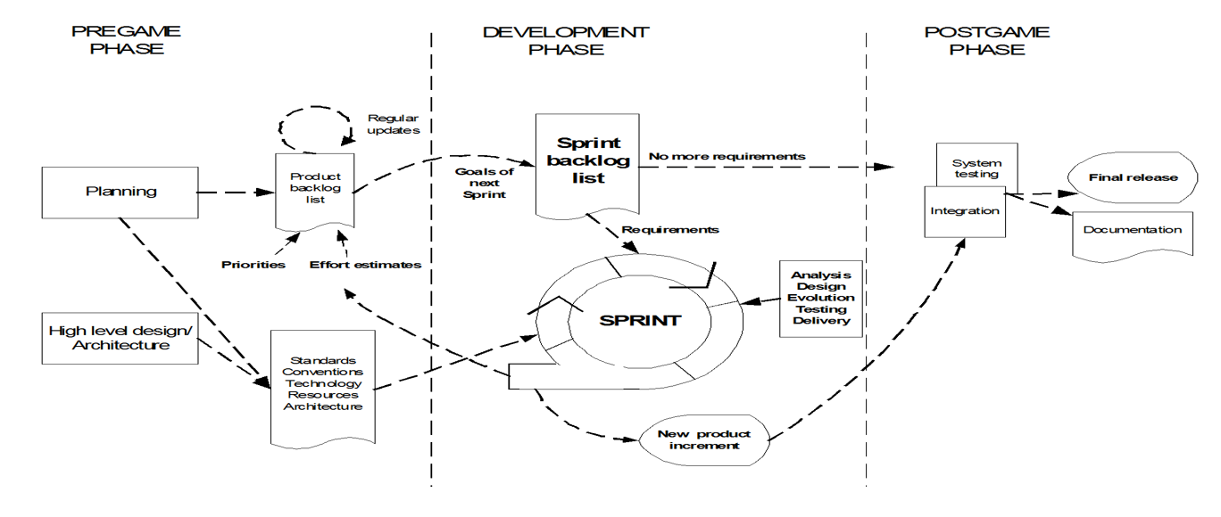
- Post-game Phase

1.Pre-Game: The pre-game phase includes two sub-phases
a)Planning
▪ Define the system and create a Product Backlog based on list of requirements.
▪ Prioritize tasks and estimate effort.
▪ Continuously update the backlog. ▪
Set up the team, tools, risks, and approvals.
b) Architecture
▪ Plan the system's high-level design.
▪ Identify changes if updating an existing system and decision are made on basis of review

2. Development Phase
The Development Phase is carried out through short and iterative Sprints.
- Each Sprint contains a selected group of user stories from the Product Backlog.
- Requirements are analyzed, designed, developed, integrated, and tested within each Sprint.
- Completed features are reviewed and demonstrated at the end of the Sprint.
- Feedback can be used to improve the next Sprint.
For example, the development can be divided into:
Sprint 1 – Common Authentication
- Create Account
- Login
- OTP Verification
- Forgot Password
- Change Password
- Manage Profile
- Logout
Sprint 2 – Patient Emergency Services
- Request Emergency (SOS)
- Share Live Location
- Assign Nearest Ambulance
- Track Ambulance
- View Nearby Hospitals
- Request Blood Donor
- Receive Emergency Notifications
Sprint 3 – Ambulance Driver Services
- Receive Nearby Emergency Requests
- Accept Emergency Request
- Navigate to Patient
- Update Emergency Status
- View Emergency Details
Further Sprints can implement Hospital Administrator, Blood Donor, and System Administrator functionalities.

3. Post-Game Phase
The Post-game phase begins when the planned backlog requirements have been completed and the system is ready for final release.
- Integrate all completed modules.
- Perform comprehensive system testing.
- Verify emergency workflows from SOS request to ambulance arrival.
- Test communication between patients, ambulance drivers, hospitals, and blood donors.
- Perform security and performance testing.
- Fix remaining defects and issues.
- Prepare final system documentation.
- Deploy the finalized ShebaLink system.

Why Scrum Model?
I. Efficient Backlog Prioritization (Product Backlog)
Scrum uses a prioritized Product Backlog, which allows the ShebaLink team to implement the most critical emergency features first. Features such as Request Emergency (SOS), Share Live Location, Assign Nearest Ambulance, and Track Ambulance can be prioritized over secondary administrative or reporting features. This ensures that the core emergency response functionality is available early in the development process.
II. Multi-Role Feature Management
ShebaLink involves multiple user roles, including Patient, Ambulance Driver, Hospital Administrator, Blood Donor, and System Administrator. Scrum allows the requirements of each role to be converted into separate user stories and organized systematically. This makes the development and responsibility management easier for the project team.
III. Iterative Development Through Sprints
Scrum divides development into short Sprints. Instead of waiting until the entire emergency response system is completed, the team can deliver working features incrementally. For example, authentication can be completed first, followed by patient emergency services, ambulance driver services, hospital services, and blood donor services.
IV. Continuous Improvement and Feedback
Emergency response systems may require changes based on testing and user feedback. Scrum allows the team to review completed features after each Sprint and modify future requirements accordingly. For example, feedback from testing the ambulance tracking feature can be used to improve location updates, emergency status handling, or notification functionality in subsequent Sprints.
V. Continuous Testing and Quality Assurance
Scrum supports continuous testing throughout development rather than testing the complete system only at the end. Each completed user story can be tested against its Acceptance Criteria before being moved to the Done stage. This is particularly important for ShebaLink because emergency-related features must work reliably.
VI. Management of Real-Time and Integrated Features
ShebaLink contains several interconnected features such as GPS location sharing, ambulance assignment, ambulance tracking, hospital resource availability, emergency notifications, and blood donor requests. Scrum allows these complex features to be developed and integrated incrementally, making it easier to identify technical problems and dependencies during development.
VII. Risk Reduction for Emergency-Critical Functions
Scrum helps reduce project risk by implementing and testing high-priority emergency functions early. Problems with critical features such as SOS requests, ambulance assignment, location tracking, and emergency notifications can therefore be identified earlier rather than discovering them near the final release.

